Sudoku Solver with Open GL

*IN THE PARTIAL FULFILLMENT FOR THE AWARD*

*OF THE DEGREE OF*

MASTER’S OF SCIENCE (INFORMATION TECHNOLOGY)



POST GRADUATE GOVERNMENT COLLEGE, SECTOR 11, CHANDIGARH (2021-22)

AFFILIATED TO



**SUBMITTED BY:                                                           SUBMITTED TO:**

**Dhruv Kaith                                                                  Mr. Hardeep**

**Roll - 4503**

**PREFACE**

This project report is submitted in partial fulfilment of the requirements for the award of the degree of “Master of Computer Science (Information Technology)”

 The project report is prepared for the project completed during the course of M.SC.(IT),3rd Semester undertaken at Post Graduate Government College, Sector 11 as a part of the M.SC.(IT),3rd Semester curriculum as prescribed by Panjab University, Chandigarh. The project report includes some background information about the college and information about the services in which the college deals in.

The purpose of this report is to assemble under one cover a sufficient body of knowledge about management and development of a successful project. The following quotes outline the basic idea behind this technical report. This report assembles various functions like planning, organizing, designing, testing, and maintenanceof the Sports club management developed during the training.

This report is about the adaptation of the techniques of project development and reflects the practice and methods of this project.-

DECLARATION

I declare that the Project Report on **“Sudoku Solver”**  is the result of the original work done by me and to the best of my knowledge.

I have undergone all the necessary requirements and formalities with the college that are necessary for the submission of this Project Report.

This Project Report is submitted for partial fulfilment of all wards of the degree of **“M.SC. (IT), 3rd Semester”** under Panjab University, Chandigarh.

**Dhruv 4503**

Above statement by the candidates is true to the best of my knowledge.

**(Mr Hardeep)**

**ACKNOWLEDGEMENT**

A formal statement of acknowledgement is hardly sufficient to express our gratitude towards the personalities who have helped us to undertake and carry out this project. I hereby convey my thankfulness and obligation to all those who are providing us valuable help, support and guidance to carry on this project.

First and foremost, I express my gratitude towards **Mr Hardeep**. His keen interest and encouragement has been of immense help to me. He gave me unending support and helped me in numerous ways from the stage when the idea of the project was conceived. He was always there to hear me and to give advice. He taught me how to ask questions and express my ideas. He showed me different ways to approach a research problem and the need to be persistent to accomplish any goal. He had taken pain to go through the project and make necessary corrections as and when needed.

**NAME      ROLL NO.**

Dhruv 4503

**CERTIFICATE**

To whom it may concern

This is to certify that the project has been submitted by Dhruv Kaith pursuing MSC.IT(3st semester) at PGGC-11 Chandigarh, undertook a project entitled “Sudoku solver” which is a record of  Bonafede  work carried out by them under my supervision. In my knowledge, this work has not been submitted, either in part or in full, to any other University or institute for the award of degree. He has submitted the report in time. He has done good work and have fulfilled all the requirements.

Project Guide:

Mr. Hardeep

Assistant Professor

PGGC-11

Chandigarh

PLACE : CHANDIGARH

DATE :

**Brief Introduction about GC11**

**and IT Department**

Government College, Sector 11, Chandigarh is as old and as young as the City Beautiful. Its growth and expansion have kept pace with the growth and expansion of the city.

The college was established on May 26, 1953. The college was envisaged as a leading institution having its own distinct impression on the educational and cultural map of the ‘City Beautiful’. A prestigious temple of learning, (just in the footsteps of famous Govt College, Lahore). Being the first college in the city, it has proved itself eminently worthy of its role as a torch-bearer in the whole gamut of broad-based instruction. The college aims at providing congenial atmosphere and constructive channels to its young scholars for the fullest development of their multi-dimensional personalities. **‘Higher and Still Higher’** is the motto of the college.

During the past 50 years the college has scaled many a glorious height, has taken tremendous strides and carved for itself a secure niche in the educational edifice in this part of the country. It has consistently won laurels in the spheres of academics, sports and other creative activities. A cross-section of our student community has the enviable position in administrative services, education, medicine, engineering, business, industry, and even politics. They are the trend setters for the present generation of students.

IT DEPARTMENT

M.Sc.(IT) was started in 2000. B.C.A. classes were introduced in 1999. B.Sc Computer Science was introduced in july 2004. H.O.D. of the Department is Mr. Bansal. The term IT is related to Information Technology. There are well maintained labs with new infrastructure where students are provided guidance about the software development and other terms related to IT, IT fests are organized every year in which students take part and explore their knowledge. Faculty of the department is very helpful and intelligent.

**Project Description**

|  |  |
| --- | --- |
| Project Name | Sudoku Solver |
| Project type | Development Project |
| Library | Open GL |
| Tools | Code blocks |
| Front end | C++ |

Overview Of The Project

The project “SUDOKU Solver” is developed using C++. In this project I make use of only standard libraries of C++ with file handling. File handling is used to provide input for the 9x9 matrix for the Sudoku Solver.

This project Solves most Sudoku boards. You can input value from a file, select some standard boards or indivisibly enter 81 values. The zero values in array represents empty values. When you input the values in the program, it will try to solve the problem and display output, if a solution exists for the particular board.

Future scope of the project

Further development can be made to this project to improve it. The values for sudoku board can be entered through and image recognition API. A GUI can be added to make this application more user friendly and widely accessible. A board generator can be added to it to check many usable boards to feed as input to this program.

**Hardware & Software Requirements**

**SOFTWARE REQUREMENTS:**

* Code Blocks
* Open GL

**HARDWARE REQUIRMENTS**

* + Pentium 4 Processor
  + 512 MB RAM

Flow chart

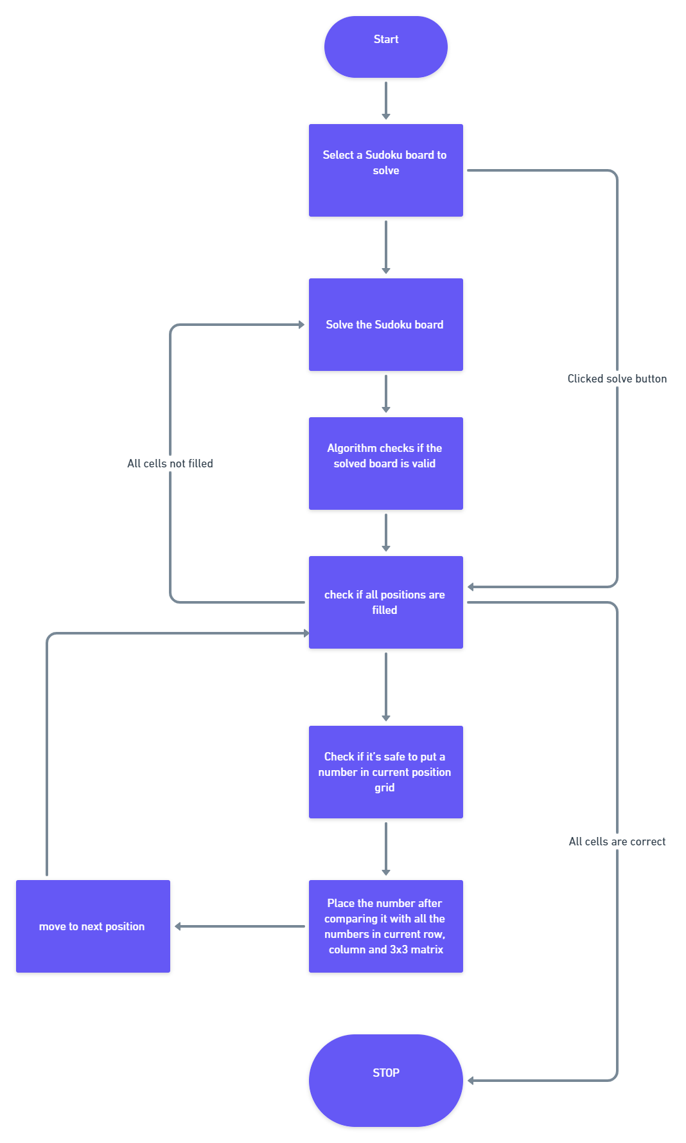

What is Sudoku?

Currently, Sudoku puzzles are becoming increasingly popular among the people all over the world. The game has become popular now in a large number of countries and many developers have tried to generate even more complicated and more interesting puzzles. Today, the game appears in almost every newspaper, in books and in many websites.

**Sudoku** originally called **Number Place**) is a logic-based, combinatorial number-placement puzzle. In classic sudoku, the objective is to fill a 9×9 grid with digits so that each column, each row, and each of the nine 3×3 sub grids that compose the grid (also called "boxes", "blocks", or "regions") contain all of the digits from 1 to 9. The puzzle setter provides a partially completed grid, which for a well-posed puzzle has a single solution.

The modern Sudoku was most likely designed anonymously by Howard Garns, a 74-year-old retired architect and freelance puzzle constructor from Connersville, Indiana, and first published in 1979 by Dell Magazines as Number Place (the earliest known examples of modern Sudoku). Garns's name was always present on the list of contributors in issues of *Dell Pencil Puzzles and Word Games* that included Number Place, and was always absent from issues that did not. He died in 1989 before getting a chance to see his creation as a worldwide phenomenon. Whether or not Garns was familiar with any of the French newspapers listed above is unclear.

Fig.1 shows an example of puzzle.

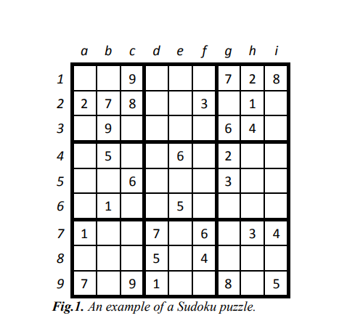

Problem Description

**This program concerns itself with solving a sudoku board that is provided by the user. The board can be manually entered by the user either through a file, or by entering 81 values individually. Program then applied backtracking method to solve the problem. This method is often also knows as brute force method. It will apply all possible solutions till it has arrived at a possible solution. It will get solution for most sudoku boards but will show an error that the board Is not a valid one, if that is the case.**

**Backtracking Algorithm**

RecursiveBacktrackning(Grid[][]){

Grid[][]*//global*

 solvePuzzle(row,col){

**if** (no more choices): the puzzle is solved**!**

 If (Grid[row][col]**=** notEmpty):

move to the next square.

**for** 1 to 9: **if**(checkRow(row,col,num)**&**checkCol(row,col,num)**&**checkGrid(row,col,num){

Grid[row][col]**=** num;

move to the next square

}

**if** **not** valid number is found go the previous square that was recently filled

 }

}

**Complexity Analysis:**

* **Time complexity:** O(n2).   
  For every unassigned index there are 9 possible options in n*n grid so the time complexity is this.
* **Space Complexity:** O(n2).   
  To store the output array a matrix is needed.

Screenshots

